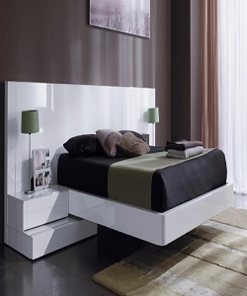

Modern Style Poliform Bed

$362.45

Availability: In stock

Description

modern twin platform bed with drawer. It has two parts one is bed frame and second is drawer then it is easy to place in room. The with color inhense the beauty of your room and the unique frame will you glide. Assembly required. Other different range beds are also available.